Saturday Feb. 15th at 12:00 p.m. NOON
ABSOLUTE!
ABSOLUTE!
GUNS - AMMO - WATCHES

at Leinbach Auction Gallery
9497 N NC Hwy 150, Clemmons, NC 27012
Estate of Wayne Deal Sr. (Deceased)
175+ Guns! 225+ Pocket Watches!
Preview Friday Feb. 14th 12:00 Noon-6 p.m. & Doors open Saturday 9 a.m.
Guns sold 12:00pm Noon-2 p.m.; Watches sold at 2 p.m.; Guns resume at approximately 3 p.m.
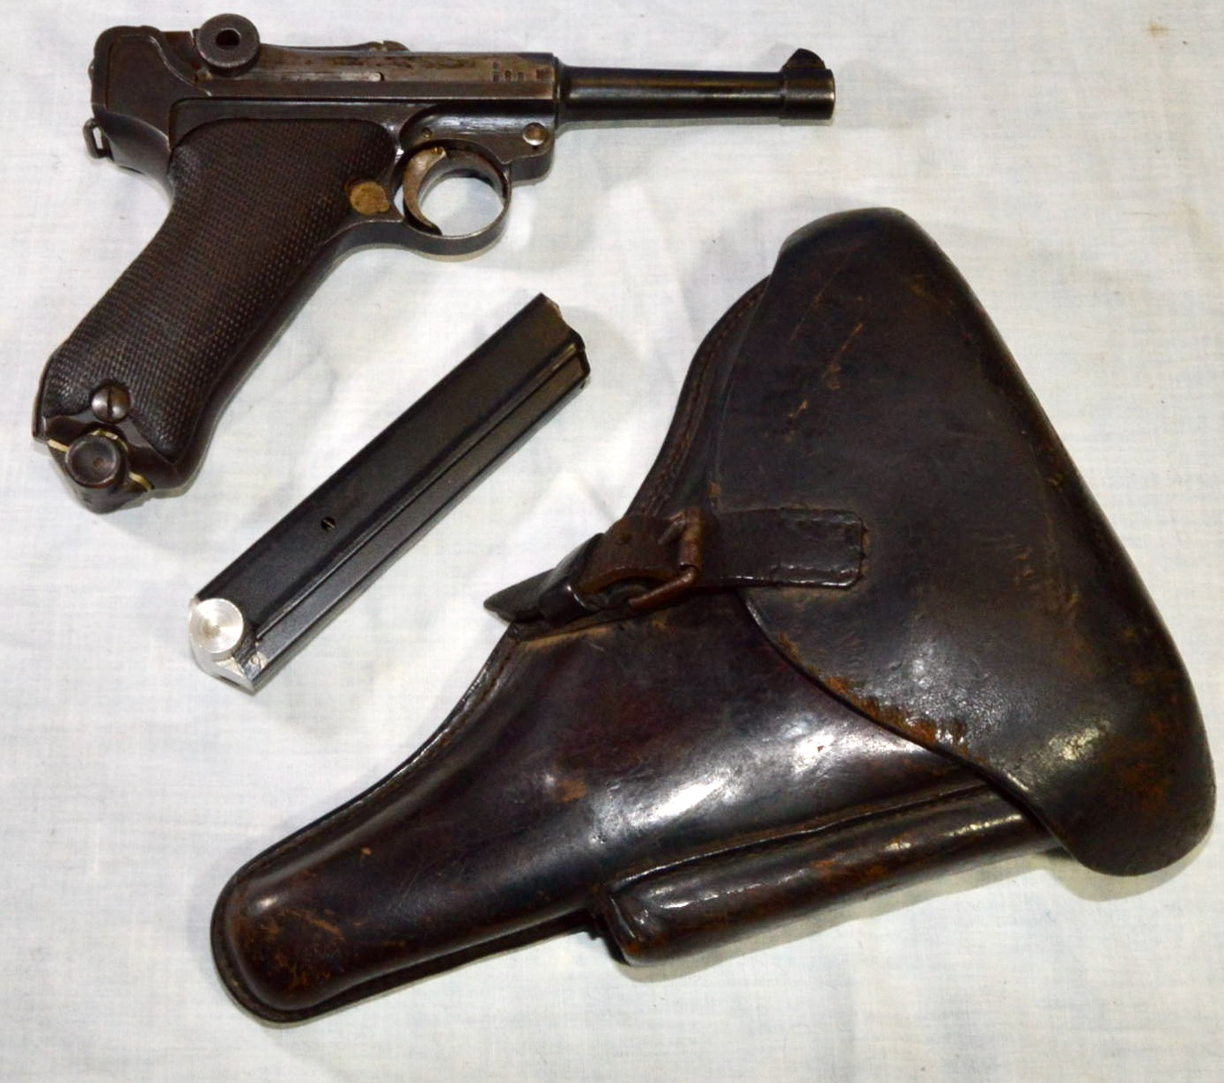

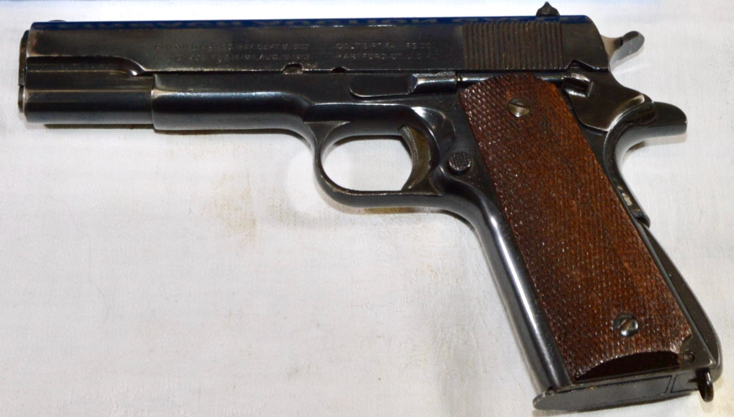
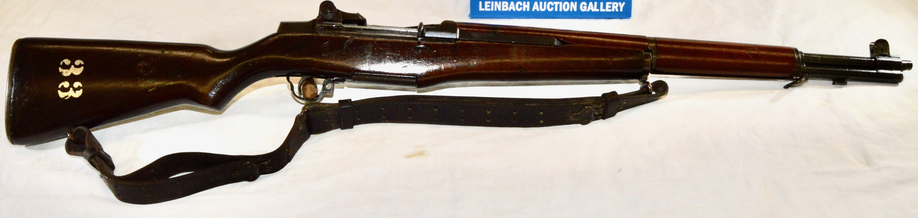

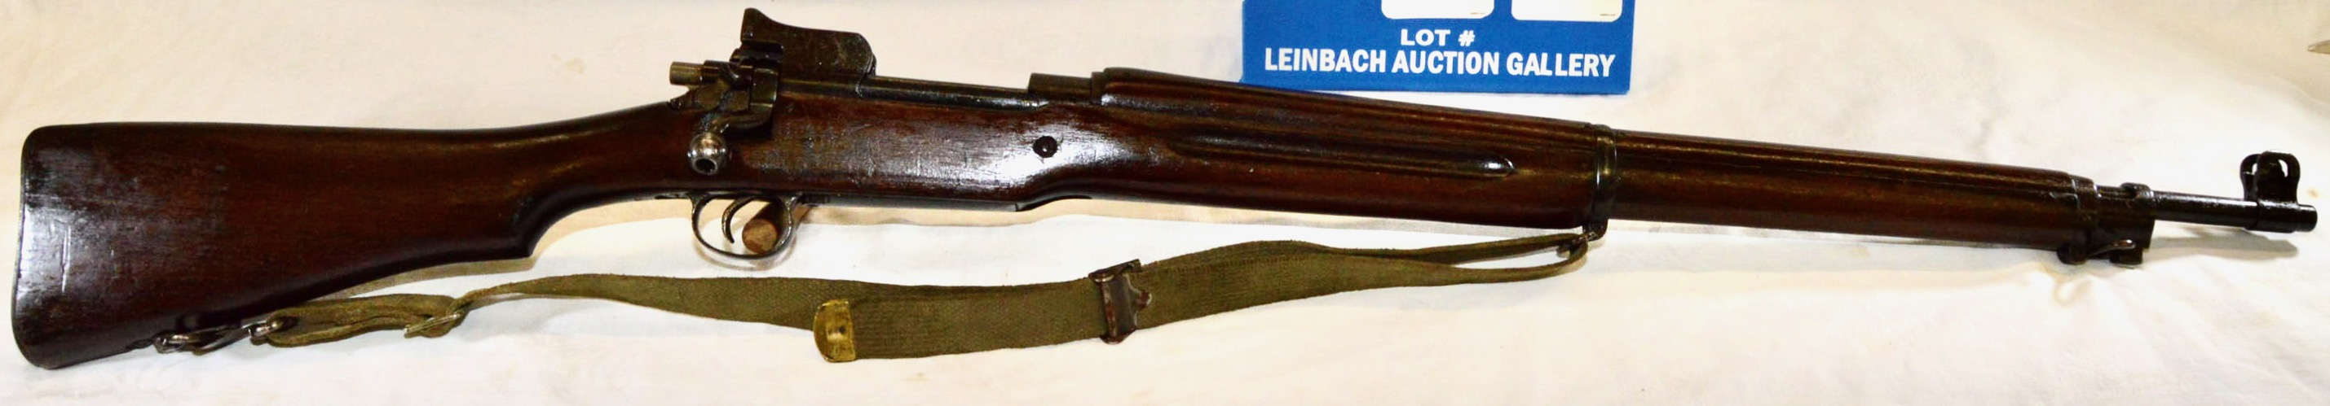
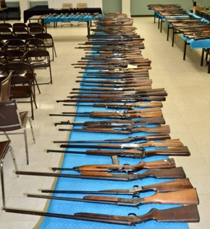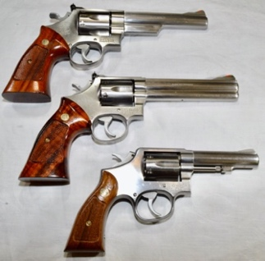
Extensive Military & Lever Action Collection
M1 Garand – M1 Carbines – Eddystone Rifles – Lugers – SKS Rifles – Arisakas with ‘Mums’ – Mosin-Nagants – Enfields – Mausers – Springfield Trapdoors – Thompson .45 Auto – etc.
Large Selection of Early Lever Action Rifles: Multiple Winchesters, Marlins; Rare Calibers; Several with Archive Letters
Smith & Wesson Pistols – Colt .45s – etc.
Several Air Rifles – Other Shotguns, Rifles, Falling Blocks, Bolt Actions, Automatics
Lots of Ammo – Reloading Equipment, Supplies – Holsters – WWII Helmet – Bayonets – Small Gun Safe – Hundreds of Pounds of Lead!
225+ Pocket Watches
Hamiltons – Illinois – Walthams – Plus Early Automobile Clocks & Wristwatches

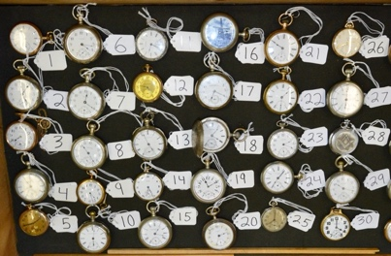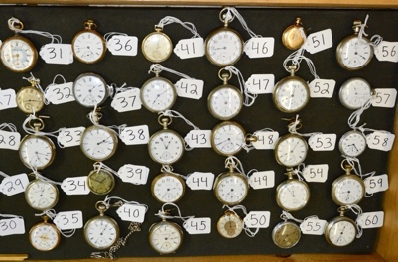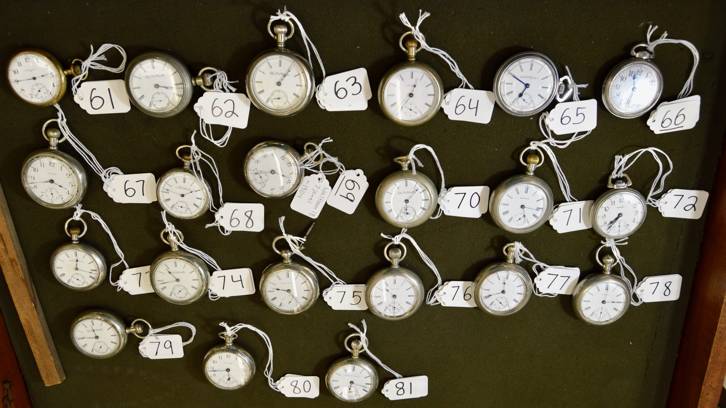
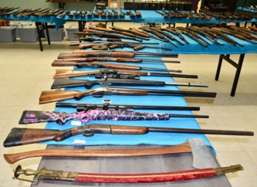
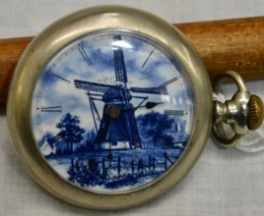
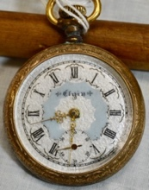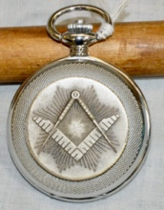
The GALLERY GRILL will be HOT!
ALL Federal Firearm Laws Apply
PAYMENT TERMS: LIVE FLOOR BIDDERS PAY NO BUYER’S PREMIUM!

Pay with Cash – Check – Visa – MasterCard – Debit Card.

Absentee and phone bids add 20% Buyer’s Premium. (Contact TL5871@bellsouth.net for Absentee Bid Form.)
THE ESTATE SETTLEMENT PROFESSIONALS
OWNER / AUCTIONEER / BROKER / APPRAISER – TODD A. LEINBACH
(336) 764-5146 or CELL (336) 416-9614
NCAL #5871 NCAFL #6856 NCREBL #199922 Licensed FFL Dealer
AuctionZip.com (ID#5969) / LeinbachAuctions.net

