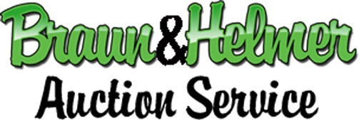

Absentee Bidder Form

Bidder Name: ___________________________________________

Billing Address: __________________________________________

City: _____________________ State: __________ Zip: ___________

Phone: (______)_____________ Email: _______________________

Absentee bids must be guaranteed by a valid credit card number and expiration date, unless other arrangements have been made. If you are a successful bidder, you may pay by a different method if you wish.

Name on Card: ______________________________

Valid Card #___________________ Expiration: ______ CVV _____

Please execute these binding bids competitively on my behalf. I have read and agree to the Terms written in the auction catalog, and the RULES listed below on this form.

Signature: ______________________________ Date: ____________

Please list the MAXIMUM amount you wish to bid. We will try to buy for you at the lowest possible price.

Lot # | Item Description | Dollar Amount $

RULES FOR ABSENTEE BIDDERS: 1. Absentee bids are subject to all the Auction Terms. Be sure you read and understand them. TERMS can be obtained by visiting the Braun and Helmer website 2. By sending this form, you request and authorize us to bid on the lots listed on this form up to the stated bid price. A staff member will bid on your behalf, as if you were present and bidding and will try to buy for you at the lowest possible bid. To protect the integrity of the bidding process, it is our policy not to disclose the amount of an absentee bid to other potential bidders. 3. We assume no responsibility for failure to execute these bids for any reason whatsoever. 4. All items are sold as/is where/is. 5. Bid increments are at the auctioneer’s discretion. 6 Winning bidders will be contacted approximately 48 hours after the completion of the auction. 7. Bidders are responsible for claiming their winnings after payment is received one of two ways: by pickup or shipping. Shipping must be scheduled with either the USPS or UPS and the buyer is responsible for organizing, packing, and shipment.

Send this form to David Helmer at davidghelmer@gmail.com at least 24 hours before the day of the auction. For additional information, pictures, or descriptions, contact David Helmer at (734) 360- 1733.

©2021 Auction Results – All Rights Reserved Proprietary & Confidential

